**Lab Report**

Title: Data buffering Task Performed by three Different Approaches

Notice: Dr. Bryan Runck

Author: Zhaoxu Sui

Date: 09/15/2021

**Project Repository: https://github.com/KennethSui/GIS5571/tree/main/lab0**

**Google Drive Link: https://drive.google.com/drive/folders/163esbfFNMoJqotkkuDmNppeBJRrW6b8h?usp=sharing**

**Time Spent:** 5 hours

**Abstract**

Performing buffering on a network dataset via three tools, Jupyter Notebooks in ArcPro, Jupyter Notebooks in ArcOnline, and ArcPro.

**Problem Statement**

The Esri ecosystem has many different ways that you can access the same underlying functionality. My objective is to compare and contrast performing the same simple activity - buffer a network dataset - using one dataset, MN Metropolitan Counties Road Centerlines, and three different tools: ArcPro, Jupyter Notebooks in ArcPro, Jupyter Notebooks in ArcOnline.

| **#** | **Requirement** | **Defined As** | **(Spatial) Data** | **Attribute Data** | **Dataset** | **Preparation** |
| --- | --- | --- | --- | --- | --- | --- |
| 1 | Road Buffering | Raw input dataset from MN Geospatial Commons | Road geometry |  | [Mn GeoSpatial Commons](https://gisdata.mn.gov/dataset/trans-roads-mndot-tis) | Set up ArcGIS Pro and ArcOnline |

**Input Data**

| **#** | **Title** | **Purpose in Analysis** | **Link to Source** |
| --- | --- | --- | --- |
| 1 | MN Metropolitan Counties Road Centerlines | Raw input dataset for routing analysis from MNDOT | [Mn GeoSpatial Commons](https://gisdata.mn.gov/dataset/trans-roads-mndot-tis) |

**Methods**

Method 1: Using ArcGIS Pro to perform a buffering task, which is, to be specific, the first one on the default geoprocessing tool, performing 500m buffering, and generating results.

The pictures of method running is in the google drive and the github repository.

**Results**

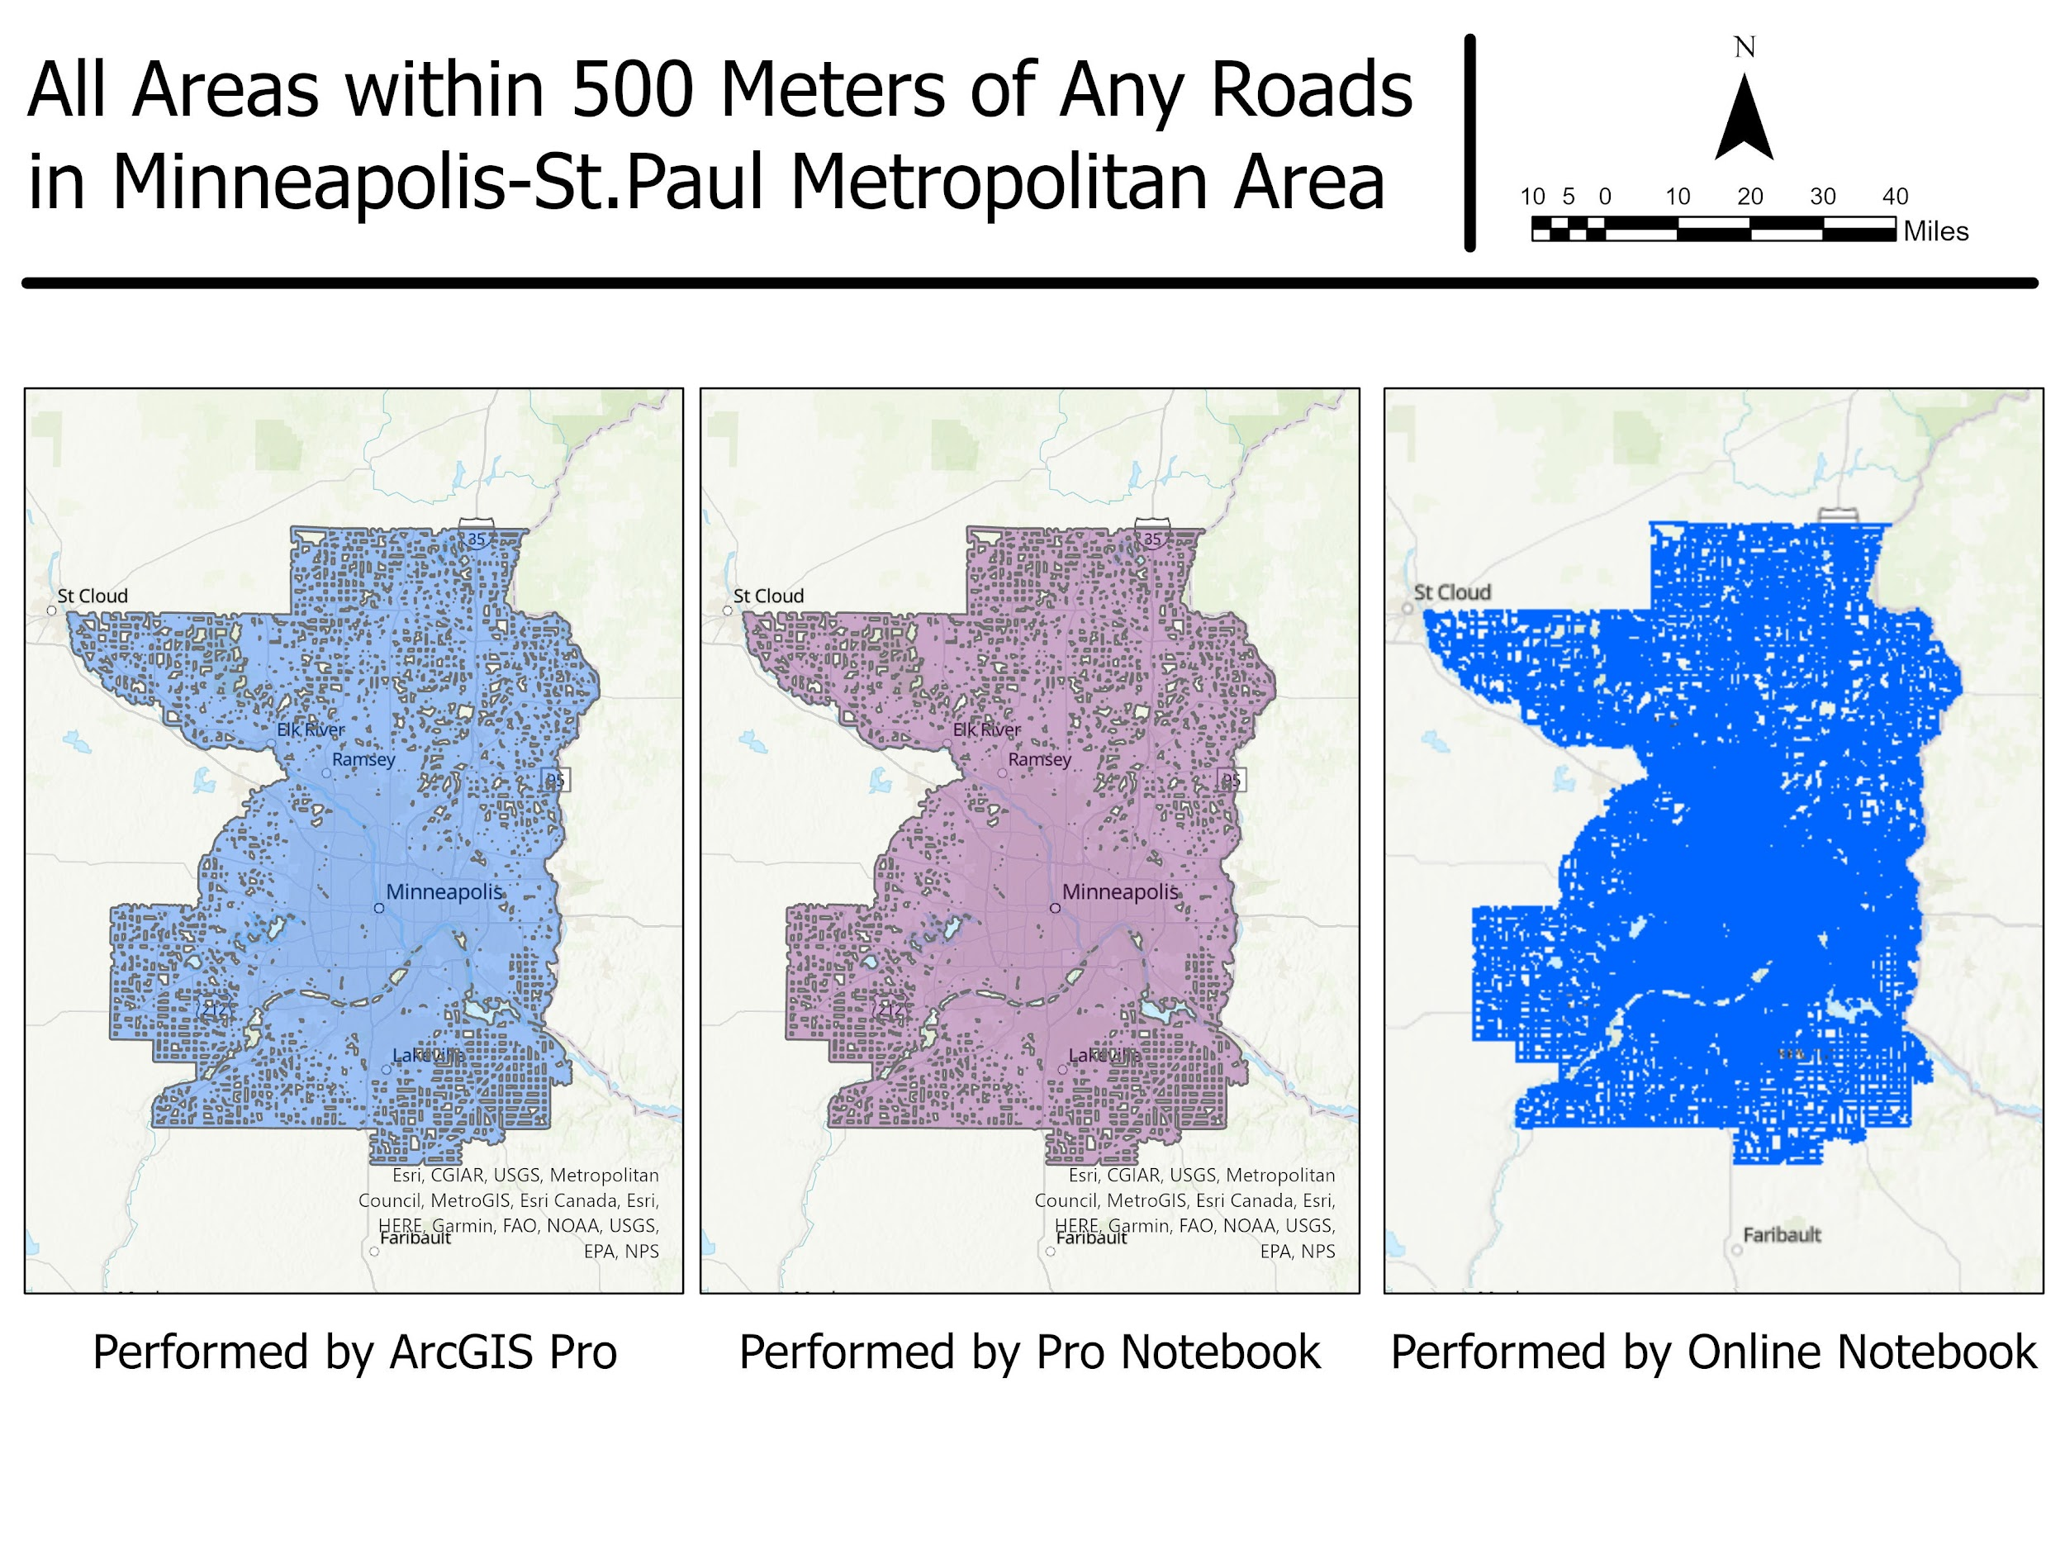

**Results Verification**

After comparing all three outputs, the result is verified as correct.

**Discussion and Conclusion**

I learned the basic set up as well as the necessary procedures to perform these three different tasks, such as how to access, how to save, and how to run the code. In the end, all the results remain the same if the code and the procedures are followed correctly.

#### GitHub

I have already set up GitHub once in my laptop last semester, but it is still a tricky part that you have to push it to the domain once I make any changes in my local repository. I believe that sometimes I will forget to do it, so I will check twice.

**References**

Get Started with Notebooks. Esri. [https://doc.arcgis.com/en/arcgis-online/get-started/components-of-the-notebook-editor.htm](https://doc.arcgis.com/en/arcgis-online/get-started/components-of-the-notebook-editor.html)

Notebooks in ArcGIS Pro. Esri

<https://pro.arcgis.com/en/pro-app/latest/arcpy/get-started/pro-notebooks.htm>

**Self-score**

*Fill out this rubric for yourself and include it in your lab report. The same rubric will be used to generate a grade in proportion to the points assigned in the syllabus to the assignment.*

| **Category** | **Description** | **Points Possible** | **Score** |
| --- | --- | --- | --- |
| **Structural Elements** | All elements of a lab report are included **(2 points each)**:  Title, Notice: Dr. Bryan Runck, Author, Project Repository, Date, Abstract, Problem Statement, Input Data w/ tables, Methods w/ Data, Flow Diagrams, Results, Results Verification, Discussion and Conclusion, References in common format, Self-score | 28 | **28** |
| **Clarity of Content** | Each element above is executed at a professional level so that someone can understand the goal, data, methods, results, and their validity and implications in a 5 minute reading at a cursory-level, and in a 30 minute meeting at a deep level **(12 points)**. There is a clear connection from data to results to discussion and conclusion **(12 points)**. | 24 | **24** |
| **Reproducibility** | Results are completely reproducible by someone with basic GIS training. There is no ambiguity in data flow or rationale for data operations. Every step is documented and justified. | 28 | **28** |
| **Verification** | Results are correct in that they have been verified in comparison to some standard. The standard is clearly stated **(10 points)**, the method of comparison is clearly stated **(5 points)**, and the result of verification is clearly stated **(5 points)**. | 20 | **20** |
|  |  | 100 | **100** |